Record: 776306

|  |  |  |  |
| --- | --- | --- | --- |
| Owner | Tony Chen | LTFRONT | 6 |
| Address | SHORE ROAD | LTDEPTH | 1 |
| FULLVAL | 0 | BLDFRONT | 0 |
| AVLAND | 0 | BLDDEPTH | 0 |
| AVTOT | 0 | STORIES | 1 |
| BLDGCL | Q9 – miscellaneous outdoor recreation facility |  |  |

Anomalies:

|  |  |  |  |  |  |  |  |
| --- | --- | --- | --- | --- | --- | --- | --- |
| variables | R4 | R7 | R1_zip5 | R4_zip5 | R7_zip5 | r4_taxclass | r7_taxclass |
| z-score | 181.45 | 165.73 | 79.34 | 423.66 | 292.50 | 79.00 | 72.20 |

Missing values:  
ZIP, EXMPTCL, EXCD1, AVLAND2, AVTOT2 , EXLAND2, EXTOT2, EXCD2

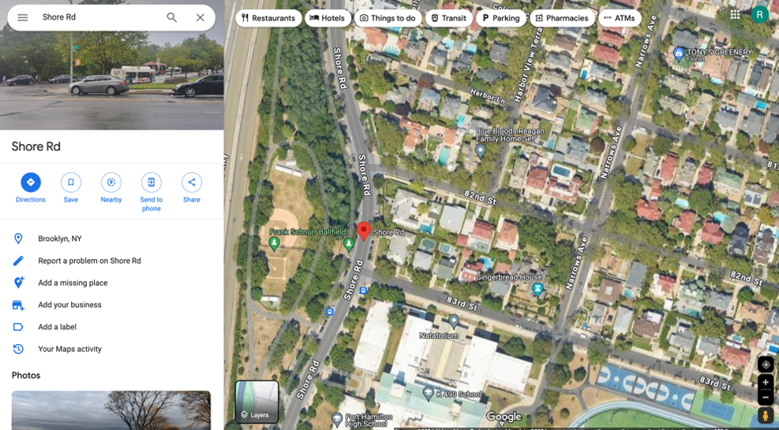

For record 776306, owned by Tony Chen and located at Shore Road, several anomalies and missing values are evident. The property details show that FULLVAL, AVLAND, AVTOT, BLDFRONT, and BLDDEPTH are all listed as 0, which is highly unusual and suggests incorrect data entry. Additionally, building class is Q9 – miscellaneous outdoor recreation facility, but this place is in a residential area.  
Additionally, the disproportionate dimensions with LTFONT at 6 and LTDEPTH at 1 are abnormal. The high z-scores for variables like R4, R7, R1_zip5, R4_zip5 , r7_zip5, r4_taxclass, r7_taxclass indicate that these values are extreme outliers, further suggesting errors and which could be the reason why this property receives a high fraud score. Moreover, critical information such as ZIP, EXMPTCL, and EXCD1 is missing.   
The map image of the property shows it is in a built-up residential area, contradicting the recorded values of 0. This evidence points to significant inaccuracies in the property record that require thorough review and correction.

Record: 980276

|  |  |  |  |
| --- | --- | --- | --- |
| Owner | Woodmont West HOA Inc | LTFRONT | 279 |
| Address | 160 Wilcox Street | LTDEPTH | 190 |
| FULLVAL | 3670 | BLDFRONT | 15 |
| AVLAND | 89 | BLDDEPTH | 30 |
| AVTOT | 92 | STORIES | 1 |
| BLDGCL | Z0 – Tennis court, pool, shed, etc. |  |  |

Anomalies:

|  |  |  |  |  |  |  |  |  |
| --- | --- | --- | --- | --- | --- | --- | --- | --- |
| variables | R4 | R7 | R1_zip5 | R4_zip5 | R7_zip5 | R1_taxclass | R4_taxclass | r7_taxclass |
| z-score | 27.95 | 67.07 | 10.98 | 49.29 | 216.09 | 216.10 | 225.05 | 344.28 |

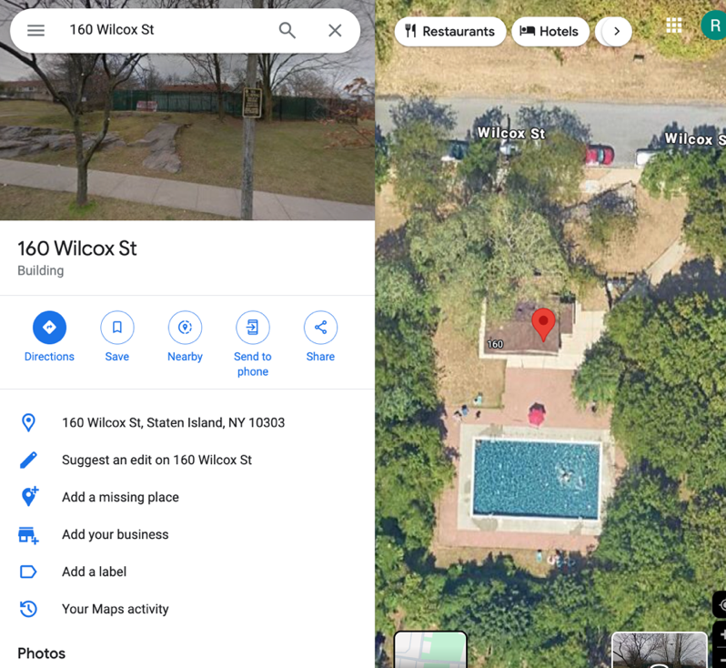

Missing values:  
EXLAND, EXTOT, EXCD1, EXLAND2, EXTOT2, EXCD2

For record 980276, owned by Woodmont West HOA Inc. and located at 160 Wilcox Street, there are several notable anomalies and missing values. The property has FULLVAL, AVLAND, AVTOT values that are significantly lower than expected, with scores of 3670, 89, and 92 respectively, which are unusual for a property of its size and location. The high z-scores for variables such as R4, R7, R1_zip5, R4_zip5, R7_zip5, R1_taxclass, R4_taxclass, r7_taxclass indicate extreme outliers, suggesting potential errors in the data. Moreover, critical information such as EXLAND, EXTOT, and EXCD1 is missing, which further complicates accurate assessment. The map image shows the property in a developed residential area, contradicting the low values recorded. This evidence highlights significant inaccuracies in the property record, necessitating a thorough review and correction to ensure accurate property assessment and records.

Record: 686922

|  |  |  |  |
| --- | --- | --- | --- |
| Owner | WILLIAM J FREED | LTFRONT | 437 |
| Address | CYPRESS AVENUE | LTDEPTH | 421 |
| FULLVAL | 25100000 | BLDFRONT | 0 |
| AVLAND | 11295000 | BLDDEPTH | 0 |
| AVTOT | 11295000 | STORIES | NaN |
| BLDGCL | Z8 - cemetery |  |  |

Anomalies:

|  |  |  |  |  |  |  |  |
| --- | --- | --- | --- | --- | --- | --- | --- |
| variables | R3 | R2_zip5 | R3_zip5 | R5_zip5 | R6_zip5 | R8_zip5 | R9_zip5 |
| z-score | 36.87 | 145.08 | 215.87 | 229.74 | 300.27 | 148.53 | 211.37 |

Missing values:  
EASEMENT, EXT, STORIES, EXCD2

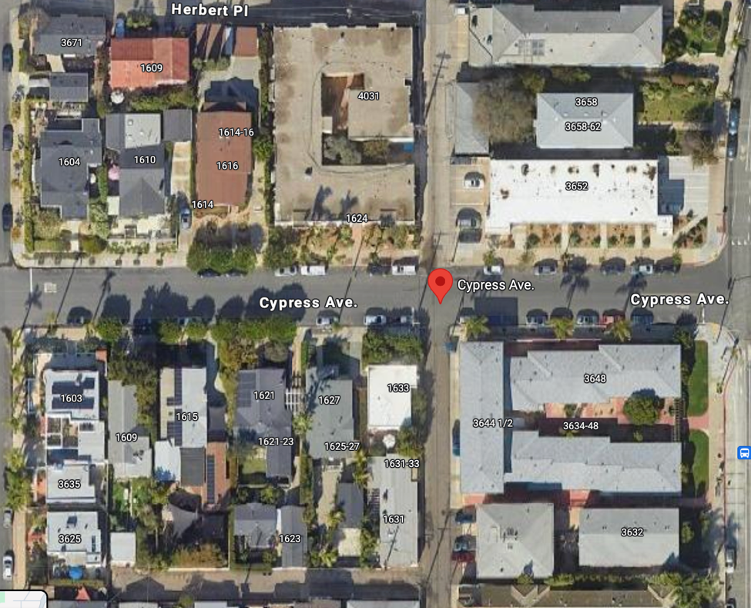For property record 980276 at Cypress Avenue, several anomalies suggest potential fraud. The property has unusually large lot dimensions (LTFRONT 437, LTDEPTH 421) and very high values (FULLVAL 25,100,000; AVLAND and AVTOT 11,295,000). However, both building frontage and depth are recorded as 0, and the number of stories is missing, which is highly improbable for such a valuable property. The high z-scores for several variables (R3, R2_zip5, R3_zip5, etc.) indicate these values are extreme outliers compared to other properties, suggesting potential errors or data manipulation. Missing critical information, such as easement, extension, and additional exemption codes, further raises suspicion. The map image of a built-up area contradicts the zero building dimensions, indicating potential fraudulent activity. Additionally, the property is classified as Z8 - cemetery, but this place is in a residential area and no sign of cementery.

Record: 1045012

|  |  |  |  |
| --- | --- | --- | --- |
| Owner | LINDA VITALONE | LTFRONT | 726 |
| Address | ERIKA LOOP | LTDEPTH | 1174 |
| FULLVAL | 2300000 | BLDFRONT | 0 |
| AVLAND | 129 | BLDDEPTH | 0 |
| AVTOT | 129 | STORIES | NaN |
| BLDGCL | V0 – zoned residential; not Manhattan |  |  |

Anomalies:

|  |  |  |  |  |  |  |
| --- | --- | --- | --- | --- | --- | --- |
| variables | R4 | R7 | R4_zip5 | R7_zip5 | R4_taxclass | R7_taxclass |
| z-score | 98.42 | 172.43 | 163.12 | 133.68 | 63.71 | 41.01 |

Missing values:  
EASEMENT, EXT, STORIES, ZIP, AVLAND2, AVTOT2, EXLAND2, EXTOT2, EXCD2

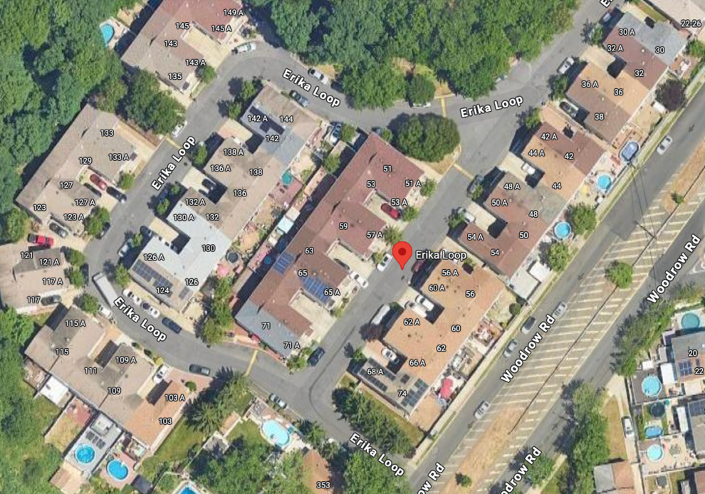

For property record 1045012 at Erika Loop, several anomalies suggest potential fraud. The property has extremely large lot dimensions (LTFRONT 726, LTDEPTH 1174) and a high FULLVAL of 2,300,000, yet the building frontage and depth are both recorded as 0, and the number of stories is missing, which is unrealistic for such a valuable property. The high z-scores for variables like R4, R7, and others indicate extreme outliers, suggesting inaccuracies. Additionally, critical information such as easement, extension, stories, zip code, and additional assessed values is missing. The map image of a developed area contradicts the zero building dimensions. These discrepancies strongly suggest inaccuracies in the property record, indicating potential fraudulent activity.

Record: 855940

|  |  |  |  |
| --- | --- | --- | --- |
| Owner | LITTLE SISTERS OF THE POOR | LTFRONT | 402 |
| Address | 110-39 SPRINGFIELD BLVD | LTDEPTH | 545 |
| FULLVAL | 10400000 | BLDFRONT | 0 |
| AVLAND | 3330000 | BLDDEPTH | 0 |
| AVTOT | 4680000 | STORIES | NaN |
| BLDGCL | M4 - convent |  |  |

Anomalies:

|  |  |  |  |  |  |  |
| --- | --- | --- | --- | --- | --- | --- |
| variables | R2_zip5 | R3_zip5 | R5_zip5 | R6_zip5 | R8_zip5 | R9_zip5 |
| z-score | 96.97 | 110.65 | 122.51 | 135.37 | 116.39 | 119.78 |

Missing values:  
EASEMENT, EXT, STORIES, EXMPTCL, EXCD2

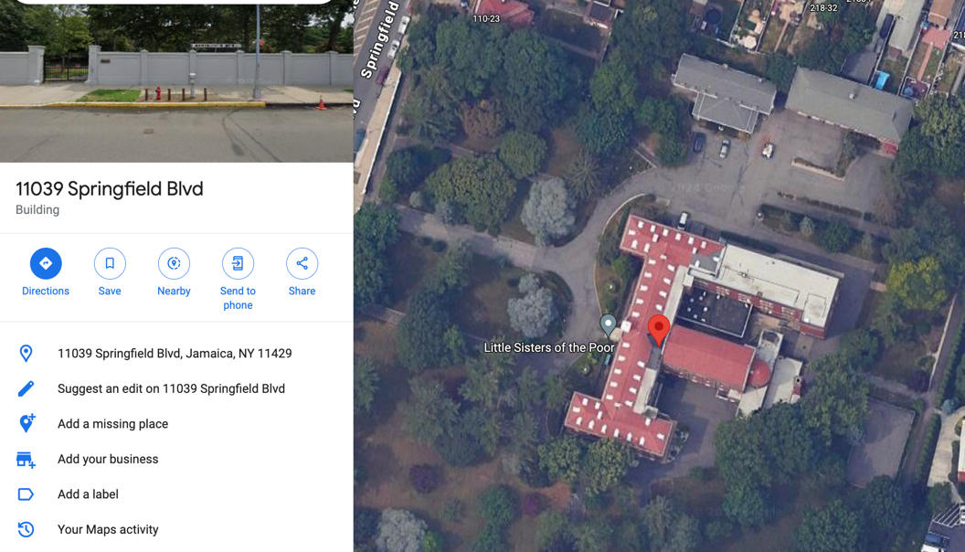For property record 866940 at 110-39 Springfield Blvd, several anomalies suggest potential fraud. The property has large lot dimensions (LTFRONT 402, LTDEPTH 545) and a high FULLVAL of 10,400,000, with AVLAND and AVTOT valued at 3,330,000 and 4,680,000 respectively. However, both building frontage (BLDFRONT) and depth (BLDDEPTH) are recorded as 0, and the number of stories is missing, which is highly improbable for such a high-value property. High z-scores for multiple variables (R2_zip5, R3_zip5, etc.) indicate these values are extreme outliers. Additionally, critical information such as easement, extension, stories, exemption codes, and additional assessed values is missing. The map image shows a substantial building, contradicting the zero building dimensions. These discrepancies strongly suggest inaccuracies in the property record, indicating potentially fraudulent activity.